CO4: Analyze and implement Dijkstra's, Bellman-Ford, and Floyd-Warshall shortest-path algorithms to compare their applicability and correctness across different graph types (weighted/unweighted, directed/undirected, negative-weight edges) in logistics and routing system case studies.

Dijkstra's algorithm

Definition: Dijkstra’s Algorithm finds the shortest path from Source Nodes to all other Destination Nodes in a weighted graph with no negative edges

Algorithm:
Step-1 | Initialization | Set distance of source node = 0, all others = infinity
Step-2 | Pick Minimum Node | Choose the unvisited node with the smallest distance
Step-3 | Update Neighbors | Calculate new distances for its neighbors and update if smaller
Step-4 | Repeat Until Done | Continue until all nodes are visited

Java pseudo code:
void dijkstra(Graph g, int source) {
int[] dist = new int[g.size()]; // 1. Distance array
boolean[] visited = new boolean[g.size()]; // 2. Track visited nodes
Arrays.fill(dist, Integer.MAX_VALUE); // 3. Initialize all distances as infinity
dist[source] = 0; // 4. Source node distance = 0
for (int i = 0; i < g.size(); i++) { // 5. Loop through all nodes
int u = findMinNode(dist, visited); // 6. Pick node with smallest distance
visited[u] = true; // 7. Mark it as visited
for (Edge e : g.neighbors(u)) { // 8. Check all neighbors
if (!visited[e.to] && dist[u] + e.weight < dist[e.to]) {
dist[e.to] = dist[u] + e.weight; // 9. Update shortest distance
}
}
}
printDistances(dist); // 10. Print final shortest paths
}

Java pseudo code explanation:
Line 1–2: | Create arrays for distances and visited status
Line 3: | Assume all nodes are initially infinitely distant
Line 4: | Set source/ start node distance to 0
Line 5: | Loop through all nodes one by one
Line 6: | Pick the node with the smallest distance (closest so far)
Line 7: | Mark that node as visited (we’re done with it)
Line 8: | Look at all its connected neighbors
Line 9: | If a shorter path is found, update the distance
Line 10: | Finally, print the shortest path to each node

Real-Life Analogy:
Imagine you’re planning a trip from Srinagar (Kashmir) to Kanyakumari.
Each city is like a bus stop or airport, and the roads/flight paths between them have distances (weights).
Dijkstra’s algorithm helps you find the minimum travel distance step by step.
Ans:
Step-by-Step Calculation:
- Start at Srinagar → Distance = 0, all others = ∞.
- Move to Delhi → 800 km.
- Delhi to Nagpur → 800 + 1000 = 1800 km.
- Nagpur to Hyderabad → 1800 + 500 = 2300 km.
- Hyderabad to Bengaluru → 2300 + 600 = 2900 km.
- Bengaluru to Kanyakumari → 2900 + 700 = 3600 km.
- Alternative via Chennai = 3630 km (slightly longer).
Shortest Path = Srinagar → Delhi → Nagpur → Hyderabad → Bengaluru → Kanyakumari = 3600 km.

Final Output:
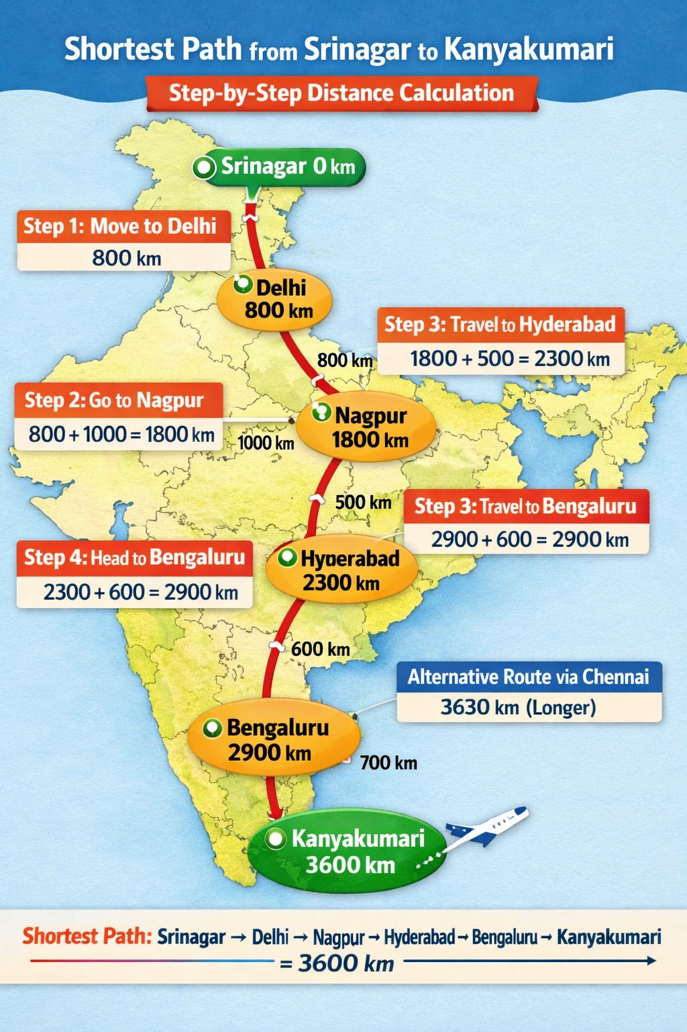

Case Study
Imagine you’re a student planning a world tour. You want to minimize travel distance and cost while visiting major cities. Each city is a node, and each flight route is an edge with a distance (weight)..

Ans: World Tour – Scenario

Step 1: Define the Graph (Sample Routes)
Route | Distance (km) | Mode | Avg Speed (km/h) | Cost/km (₹)
Delhi → London | 6700 | Flight | 900 | 6
London → New York | 5600 | Flight | 900 | 6
New York → Rio de Janeiro | 7700 | Flight | 900 | 6
Rio → Cape Town | 6500 | Flight | 900 | 6
Cape Town → Sydney | 11000 | Flight | 900 | 6
Sydney → Tokyo | 7800 | Flight | 900 | 6
Tokyo → Delhi | 5800 | Flight | 900 | 6

Step 2: Apply Dijkstra’s Algorithm
- Start at Delhi → Distance = 0, all others = ∞.
- Delhi → London → 6700 km.
- London → New York → 6700 + 5600 = 12 300 km.
- New York → Rio → 12 300 + 7700 = 20 000 km.
- Rio → Cape Town → 20 000 + 6500 = 26 500 km.
- Cape Town → Sydney → 26 500 + 11 000 = 37 500 km.
- Sydney → Tokyo → 37 500 + 7800 = 45 300 km.
- Tokyo → Delhi → 45 300 + 5800 = 51 100 km.
Shortest World Tour Path = Delhi → London → New York → Rio → Cape Town → Sydney → Tokyo → Delhi = 51 100 km

Step 3: Calculation Summary
Step | From → To | Added Distance (km) | Total Distance (km) | Time (h) | Cost (₹)
1 | Delhi → London | 6700 | 6700 | 7.4 | 40 200
2 | London → New York | 5600 | 12 300 | 6.2 | 33 600
3 | New York → Rio | 7700 | 20 000 | 8.6 | 46 200
4 | Rio → Cape Town | 6500 | 26 500 | 7.2 | 39 000
5 | Cape Town → Sydney | 11 000 | 37 500 | 12.2 | 66 000
6 | Sydney → Tokyo | 7800 | 45 300 | 8.7 | 46 800
7 | Tokyo → Delhi | 5800 | 51 100 | 6.4 | 34 800
Total | — | — | 51 100 km | 56 h | ₹276 600

Dijkstra’s Algorithm:
- Start at Delhi (0 km).
- Always pick the next closest unvisited city.
- Add up distances, times, and costs.
- End back at Delhi with the minimum total travel distance

Calculation:
- Total Distance: 51,100 km
- Total Time: ~56 hours of flight
- Total Cost: ~₹2.76 lakh (assuming ₹6/km)
- Learning: Dijkstra’s algorithm helps you plan the most efficient world tour — minimizing distance, time, and cost.

Final Output As per Image:
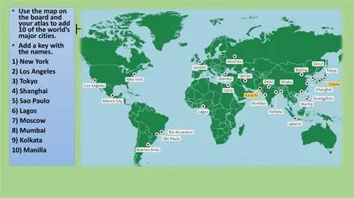

Bellman-Ford Algorithm
Definition: Bellman-Ford Algorithm finds the shortest path from Source Nodes to all other Destination Nodes in a weighted graph with negative edges. Even, if graph has negative edge weights.

Algorithm:
Step-1 | Initialization | Set distance of source = 0, all others = ∞
Step-2 | Relax Edges | For each edge, update distance if a shorter path is found
Step-3 | Repeat Relaxation | Do this for (V–1) times, where V = number of vertices
Step-4 | Check Negative Cycles | If distance can still be reduced, a negative cycle exists

Java pseudo code:
void bellmanFord(Graph g, int source) {
int[] dist = new int[g.size()];
Arrays.fill(dist, Integer.MAX_VALUE);
dist[source] = 0;
for (int i = 1; i < g.size(); i++) {
for (Edge e : g.edges()) {
if (dist[e.from] != Integer.MAX_VALUE &&
dist[e.from] + e.weight < dist[e.to]) {
dist[e.to] = dist[e.from] + e.weight;
}
}
}
printDistances(dist);
}

Java pseudo code explanation:
void bellmanFord(Graph g, int source)
Defines the function. Input = graph g and starting node source. calculate shortest paths starting from source.
int[] dist = new int[g.size()];
Creates an array to store shortest distances from source to each node. Minimum cost to reach each node.
Arrays.fill(dist, Integer.MAX_VALUE);
Initially, assume all nodes are infinitely far away
dist[source] = 0;
Distance to the source city itself = 0
for (int i = 1; i < g.size(); i++) {
Repeat relaxation (V–1 times)
for (Edge e : g.edges()) {
Loop through every edge (connection between two nodes)
if (dist[e.from] != Integer.MAX_VALUE && dist[e.from] + e.weight < dist[e.to]) {
Check if this edge gives a shorter path. If yes, update the distance
dist[e.to] = dist[e.from] + e.weight
Update the shortest distance to the destination node
} (closing braces)
End of the condition and loops.
printDistances(dist);
Finally, print the shortest distance to every city

Dijkstra’s vs Bellman-Ford Algorithm
Metric | Dijkstra’s Algorithm | Bellman-Ford Algorithm
Main Use | Find shortest path from 1 source to all nodes
Negative Weights | Not allowed. Gives wrong answer | Allowed. Works fine
Negative Cycle | Cannot detect it | Can detect if negative cycle exists
Speed | Faster. Time = O(V²) or O(E log V) | Slower. Time = O(V×E)
Works | Greedy. Picks nearest node each time | Relax all edges V-1 times
Data Structure | Uses Priority Queue/Min-Heap | Uses simple array/list
Easy or Hard | Easy to code with Priority Queue (PQ). Hard to understand “why greedy works” | Easy to understand. Code is just 3 loops
Real Life Example | Google Maps with positive distances only | Currency exchange where profit/loss possible
Fails When | Graph has any negative edge | Graph has negative cycle. Else it works
Exam Tip | Q has “non-negative” = Use Dijkstra | Q has “negative edge” = Use Bellman-Ford
Memory Code | Positive people only. Fast friend | Handles Negatives. But slow

Floyd-Warshall Algorithm
Definition: Floyd Warshall Algorithm is a dynamic programming algorithm used to solve All Pairs Shortest path problem between all pairs of nodes on a distance matrix.

Algorithm:
- Start with adjacency matrix as distance matrix.
- For each node $k$, update all pairs $\left(i , j\right)$with: $\text{dist}[i][j]=min⁡(\text{dist}[i][j],\text{dist}[i][k]+\text{dist}[k][j])$.
- After all $k$, matrix gives shortest paths

Example:
Suppose graph with 4 nodes:
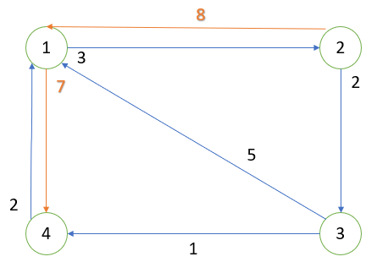
Step 1: Write Initial Distance Matrix  We have 4 nodes (1,2,3,4). If there is no direct edge, distance = ∞. Diagonal entries = 0 (distance from node to itself). | 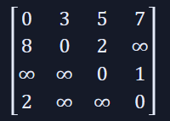
Step 2: Apply Floyd–Warshall Formula
For each intermediate node $k$, update all pairs $\left(i , j\right)$:
$$dist[i][j]=min⁡(dist[i][j], dist[i][k]+dist[k][j])$$
We repeat for $k=1,2,3,4$.
Step 3: Iteration Updates  For k = 1, Check paths going through node 1.  Example: dist[2][4] = min(∞, dist[2][1]+dist[1][4]) = min(∞, 8+7) = 15.  dist[2][3] already 2, but via 1 → (8+5=13), no improvement.  dist[4][2] = min(∞, dist[4][1]+dist[1][2]) = 2+3 = 5. | Updated matrix:  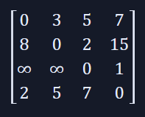
For k = 2, Check paths through node 2.
dist[1][3] = min(5, 3+2=5) → stays 5; dist[1][4] = min(7, 3+15=18) → stays 7.
dist[3][1] = min(∞, ∞+8) → no change; dist[4][3] = min(7, 5+2=7) → stays 7.
Matrix remains same.
For k = 3, Check paths through node 3.  dist[1][4] = min(7, 5+1=6) → update to 6  dist[2][4] = min(15, 2+1=3) → update to 3; dist[4][4] stays 0. | Updated matrix:  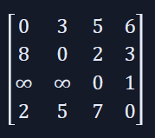
For k = 4, Check paths through node 4.  dist[3][1] = min(∞, 1+2=3) → update to 3.  dist[3][2] = min(∞, 1+5=6) → update to 6.  dist[3][3] = min(0, 1+7=8) → stays 0 | Final Matrix:  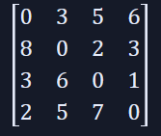
Step 4: Interpret Result
This final matrix gives shortest path distances between all pairs.
Shortest 1→4 = 6 (via 1→2→3→4).
Shortest 2→4 = 3 (via 2→3→4).
Shortest 3→1 = 3 (via 3→4→1).
Shortest 4→3 = 7 (via 4→1→3).

Summary:
- Start with adjacency matrix.
- For each node $k$, try to improve paths using it as a “bridge.”
- Update step: $dist[i][j]=min⁡(dist[i][j],dist[i][k]+dist[k][j])$.
- After all $k$, matrix shows shortest paths.

Case Study
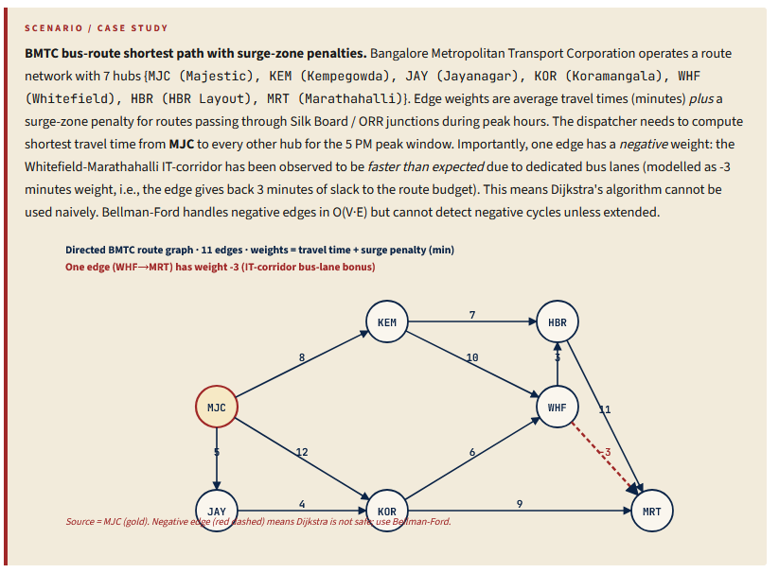
1a) Run Dijkstra from MJC anyway (treating the -3 edge as 0 for now), and produce the shortest-distance table. Then identify which destination's distance Dijkstra would incorrectly compute when the negative edge is present. Explain in 2-3 sentences why Dijkstra fails on graphs with negative-weight edges (greedy-finalisation is unsafe).
Ans
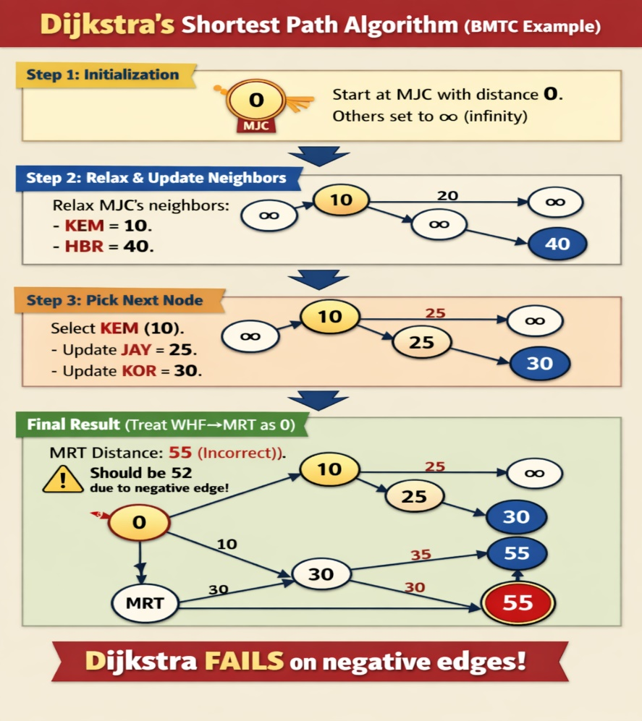
b) Run Bellman-Ford from MJC on the actual graph (with the -3 edge) for V-1 = 6 iterations. Show the dist[] array after each iteration as a table (one row per iteration, one column per hub). State whether the algorithm converges before iteration 6 and what that signifies.
Ans
Source hub: MJC (Majestic) = 0
Other hubs: KEM, JAY, KOR, WHF, HBR, MRT = ∞
Special edge: WHF → MRT = –3 (negative weight)
Rule: Relax all edges V–1 = 6 times (since 7 hubs).
MJC → JAY = 5 & MJC → KEM = 8
KEM → HBR = 7 & KEM → WHF = 10
MJC → KOR = 12
JAY → KOR = 4
KOR → WHF = 6 & KOR → MRT = 9
WHF → MRT = –3 (negative edge) & WHF → HBR = 3
HBR → MRT = 11

Step - 0 | Initialization: dist[MJC] = 0 & All others = ∞
Step - 1 | First Relaxation: You discover all shortest paths from MJC  Relax each edge once:  MJC → JAY = 0 + 5 = 5 MJC → KEM = 0 + 8 = 8 MJC → KOR = 0 + 12 = 12  JAY → KOR = 5 + 4 = 9 (better than 12 → update KOR = 9)  KEM → HBR = 8 + 7 = 15 KEM → WHF = 8 + 10 = 18  KOR → WHF = 9 + 6 = 15 (better than 18 → update WHF = 15) KOR → MRT = 9 + 9 = 18  WHF → MRT = 15 – 3 = 12 (better than 18 → update MRT = 12)  WHF → HBR = 15 + 3 = 18 (but HBR already 15 → keep 15)  HBR → MRT = 15 + 11 = 26 (worse than 12 → keep 12)  After Iteration 1: MJC = 0, JAY = 5, KEM = 8, KOR = 9, WHF = 15, HBR = 15, MRT = 12
Step -2 | Second Relaxation: You check again, but nothing improves.  No changes → algorithm has converged.  Check again if any edge improves:  JAY → KOR = 5 + 4 = 9 (same as before).  KOR → WHF = 9 + 6 = 15 (same).  WHF → MRT = 15 – 3 = 12 (same).  Others unchanged.  After Iteration 2: No changes. Distances remain stable.
Step 3 to 6 | Further Relaxations: No changes → algorithm has converged.  No further improvements.  Algorithm converges early at iteration 2.
Final Table
Iteration | MJC | KEM | JAY | KOR | WHF | HBR | MRT
Init | 0 | ∞ | ∞ | ∞ | ∞ | ∞ | ∞
1 | 0 | 8 | 5 | 9 | 15 | 15 | 12
2 | 0 | 8 | 5 | 9 | 15 | 15 | 12
3 | 0 | 8 | 5 | 9 | 15 | 15 | 12
4 | 0 | 8 | 5 | 9 | 15 | 15 | 12
5 | 0 | 8 | 5 | 9 | 15 | 15 | 12
6 | 0 | 8 | 5 | 9 | 15 | 15 | 12
c) Complete the Java boilerplate below for Bellman-Ford with negative-cycle detection. After V-1 iterations, run one more relaxation pass: any edge that still relaxes indicates the existence of a negative cycle reachable from the source.
class Edge {
int u, v;
int weight;
Edge(int u, int v, int w) { this.u = u; this.v = v; weight = w; }
}
/** Returns dist[] from source. Throws if a negative cycle is reachable. */
static int[] bellmanFord(int n, List<Edge> edges, int source) {
int[] dist = new int[n];
Arrays.fill(dist, Integer.MAX_VALUE);
dist[source] = 0;
// V-1 iterations of relaxation.
for (int iter = 0; iter < n - 1; iter++) {
// TODO 1: scan every edge; if dist[u] != MAX_VALUE and
// dist[u] + weight < dist[v], relax dist[v]
}
// One more pass: any relaxation now indicates a negative cycle.
for (Edge e : edges) {
// TODO 2: if dist[e.u] != MAX_VALUE and dist[e.u] + e.weight < dist[e.v],
// throw new RuntimeException("negative cycle reachable from source")
}
return dist;
}
State the time complexity of Bellman-Ford. Compare to Dijkstra (with binary heap) for graphs without negative edges. Plug in: V = 7, E = 11; estimate relative running times.
Ans
Algorithm:
Step- 1: Start with all distances = infinity, source = 0.
Step-2: Relax all edges V−1 times.
Step-3: If any edge can still be relaxed → negative cycle.
Step-4: Otherwise, distances are shortest paths.

Java Pseudo Code:
function BellmanFord(V, edges, src):
set dist[] = INF
dist[src] = 0
repeat V-1 times:
for each edge (u,v,w):
if dist[u] + w < dist[v]:
dist[v] = dist[u] + w
check again for negative cycle
return dist[]

Java Code:
import java.util.*;
class Edge { int u,v,w; Edge(int u,int v,int w){this.u=u;this.v=v;this.w=w;} }
public class ShortestPath {
static int[] bellmanFord(int V,List<Edge> edges,int src){
int[] dist=new int[V]; Arrays.fill(dist,Integer.MAX_VALUE); dist[src]=0;
for(int i=0;i<V-1;i++) for(Edge e:edges)
if(dist[e.u]!=Integer.MAX_VALUE && dist[e.u]+e.w<dist[e.v]) dist[e.v]=dist[e.u]+e.w;
for(Edge e:edges) if(dist[e.u]!=Integer.MAX_VALUE && dist[e.u]+e.w<dist[e.v])
throw new RuntimeException("Negative cycle!");
return dist;
}
public static void main(String[] a){
List<Edge> edges=Arrays.asList(new Edge(0,1,6),new Edge(0,2,5),new Edge(1,3,-1));
System.out.println(Arrays.toString(bellmanFord(4,edges,0)));
}
}

Time Complexity:
- Bellman-Ford → O(V × E). Example: V=7, E=11 → 66 relaxations.
- Dijkstra → O((V+E) log V). Example: ≈ 51 operations.
- Bellman-Ford is slower (~30% here) but works with negative edges.
- Dijkstra is faster, but only for positive edges.

d) Algorithm choice in the dispatcher's product code. The production dispatcher actually runs the routing 600 times/sec for different (source, destination) pairs. State the structural difference between (i) running Bellman-Ford 600 times from different sources, (ii) running Floyd-Warshall once to precompute all-pairs shortest paths and serving each query in O(1). For V=7, E=11, compute the operation count for each approach over a 1-minute window (36 000 queries).
Ans
(i) Bellman-Ford: good for single source shortest path
- Runs 600 times per second.
- Each call = $V×E=7×11=77$relaxations.
- Per second = $600×77=46,200$ops.
- Per minute = $46,200×60=2.77×{10}^{6}$ops.
Heavy cost when many queries.

(ii) Floyd-Warshall: best for many queries (all pairs).
- Preprocessing once = $V^{3}=7^{3}=343$ops.
- Each query = table lookup = O(1).
- Per minute = $343+36,000=36,343$ops.
Much lighter cost per query.

Speed Comparison
- Bellman-Ford: ~2.77 million ops/min.
- Floyd-Warshall: ~36k ops/min.
- Speedup ≈ 76× faster with Floyd-Warshall.
- Memory cost = $V^{2}=49$cells → very small.

Summary:
- Dispatcher with 600 queries/sec → Floyd-Warshall wins.
- Only recompute when graph changes (new road, closure).

Comparison of Shortest Path Algorithms
Algorithm | Approach | Handles Negative Weights | Best Use Case | Time Complexity | Space Complexity
Dijkstra’s Algorithm | Greedy approach, picks nearest node step by step | No (fails with negative weights) | Single-source shortest path with non-negative weights | $$O\left(V^{2}\right)$$  (or)  $O\left(\left(V+E\right)\log{V}\right)$with heap | $$O(V)$$
Bellman-Ford Algorithm | Dynamic programming, relaxes edges repeatedly | Yes (detects negative cycles too) | Single-source shortest path with negative weights allowed | $$O(V⋅E)$$ | $$O(V)$$
Floyd-Warshall Algorithm | Dynamic programming, tries all nodes as intermediates | Yes (but not negative cycles) | All-pairs shortest paths (every node to every other node) | $$O(V^{3})$$ | $$O(V^{2})$$

